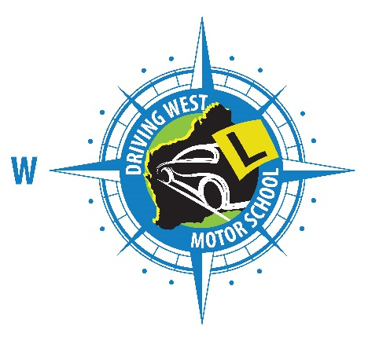

Driving Lesson Report
Lesson No.
Instructors Name Date

Summary of driving lesson:

Homework:

Overview of next driving lesson:

Please remember to give a 24hrs notice prior to cancellation or rescheduling a driving lesson.

